

**California State University Los Angeles**

**Final Group Project**

**EAGLE DASH**

**Group 4**

Ben Huang

Breanna Le

Dylan Lam

Joyce Lam

Karina Gonzalez

**SYSTEMS ANALYSIS AND DESIGN CIS 3060-02 (31279)**

**Dr. Arun Aryal**

**May 22, 2021**

**Group Information**

|  |  |  |
| --- | --- | --- |
| **Member name** | **Percent contribution** | **Activities completed by the member** |
| Karina Gonzalez | 20% | 1.4,1.5,1.6, Use Case Model/ Activity Diagram, Sequence Diagram for Restaurant Notifications |
| Ben Huang | 20% | Cover Page, 3, 3.1, 3.2, 3.3, 3.4, Use Case Model / Activity Diagram / Sequence Diagram for Food Order, Class Diagram |
| Dylan Lam | 20% | 4, 4.1, 4.2, 5, 10, Use Case Model/ Activity Diagram/ Sequence Diagram for Eagle Dasher |
| Joyce Lam | 20% | Table of Contents, 2, 2.1, 2.2, 2.3, Use Case Model/ Activity diagram/ Sequence Diagram for User |
| Breanna Le | 20% | 1, 1.1, 1.2, 1.3, 1.31, Use case Model/ Activity/ Sequence diagram for Ratings |
| **Total** | 100% |  |

**Table of Contents**

1 Introduction 3

1.1 Purpose 3

1.2 Scope 3

1.3 Definitions, Acronyms, and Abbreviations 3

1.3.1 Functional Requirements 4

1.4 References 5

1.5 Analyst Certifications 5

1.6 Overview 5

2. Positioning 6

2.1 Business Opportunity 6

2.2 Problem Statement 6

2.3 Product Position Statement 6

3. Stakeholder and User Descriptions 7

3.1 Stakeholder Summary 7

3.2 User Summary 7

3.3 User Environment 8

3.4 Key Stakeholder or User Needs 8

4. Product Overview 9

4.1 Assumptions and Dependencies 9

4.2 Licensing and Installation 9

5. Constraints 10

6. Use Case 10-26

7. Activity Diagram (Swim lane Diagrams) 27-31

8. Sequence Diagram 32-36

9. Class Diagram 37-41

10. Stakeholder Requests 42

## **1 Introduction**

This document compiles, analyzes, and describes the high-level requirements and features of a university food delivery system. It focuses on the skills that stakeholders and users need, as well as the purpose of these requirements. The use-case criteria go into great detail on how the food delivery system for universities will meet these requirements.

**1.1 Purpose**

Time is crucial to the life of a student, professor, and staff at Cal State LA. The purpose of this concept is to allow members of Cal State LA to save time and have university food delivered to them in just minutes instead of having to wait in long lines which means, people no longer have to skip meals. This concept is different from other delivery app businesses because it solely delivers food from campus to places on campus. Whether it is food from the food court, the dining halls, any existing source of places to obtain food that are located within the university can sign up with Eagle Dash. The purpose of this document is to provide a comprehensive overview of the university’s food delivery system. It will describe the system's function and features, as well as the system's interfaces, what the system will do, the constraints that it must work under, and how the system will respond to external stimuli. This paper is intended for both the system's stakeholders and developers. This is used as a source of information for the design specification and product validation.

**1.2 Scope**

The scope of this document is extended to all stakeholders associated with Eagle Dash users. Use of this system will allow members of Cal State LA (i.e. students and staff) to have the convenience of the campus’ food delivery system. This project plans and coordinates with the Eagle Dash IT team, the restaurants who sign up with Eagle Dash, the Eagle Dasher employees, and the clients of Eagle Dash, the consumers or people who use this system on the front-end. With the use of this system, it will promote employment, information technology, and job market stability. It also assists candidates, clients, and the consumers in fulfilling their requirements or wants. It captures information about both the actors and also updates the database. The system keeps track of the demand and helps in finding the appropriate candidate for a client of Eagle Dash and the consumer as well.

**1.3** **Definitions, Acronyms, and Abbreviations**

|  |  |
| --- | --- |
| **Term** | **Definition** |
| ED | Eagle Dash (the company) |
| Consumer/ User (or End User) | Person who uses this service |
| Client | Person who recruits people according to their[1] skill requirements |
| Candidate | Person who is looking for a job in this domain |
| Stakeholder | Any person with an interest in project who is not a developer |
| Database | Collection of all information monitored by this system |
| Eagle Dasher | Person who delivers food |
| IT team | Information technology service |

**1.3.1 Functional Requirements**

**Food order**

* Users schedule food delivery by using the Eagle Dash website / mobile app.
* Users use the Eagle Dash website / mobile app to select a restaurant to order their food.
* Users select their food by using the restaurant's menu.
* Users use the Eagle Dash website or the mobile app for payment.

**Ratings**

* Users must rate the delivery person, Eagle Dasher.
* Users can choose to rate restaurants.
* Users can choose to tip Eagle Dasher and Restaurant.

**Eagle Dasher**

* Eagle Dashers can accept or decline delivery requests from students/ faculty.
* Eagle Dashers can set the restaurant’s location to their Eagle Dash integrated GPS.
* Eagle Dashers can manually input the estimated time or let the Eagle Dash app automatically input the estimated time itself.
* Eagle Dashers can find the distance from their location to their destination.

**User**

* The Students / Faculty go to app store and download the Eagle Dash app or go on the Eagle Dash website to create an account to start ordering food
* Students / Faculty creates a username and password
* Students / Faculty set their location to order food
* Students / Faculty enters their phone number

**Restaurant notifications**

* The restaurant receives a notification of a pending order
* The Restaurant confirms the order received.
* The restaurant prepares the order.
* The restaurant sends notification out to the delivery person about the finished order.
* The restaurant gives the completed order to the delivery person upon arrival.

**1.4 References**

DAVID., D. A. (2015). *SYSTEMS ANALYSIS AND DESIGN: An Object-Oriented Approach With UML* (5th ed.). S.l.: JOHN WILEY & SONS.

**1.5 Analyst Certifications**

We, **Ben**, **Breanna**, **Dylan**, **Joyce**, and **Karina** have reviewed these documents and agree that they:

* Adhere to existing UML syntax and best practices.
* Are internally consistent
* Meet the needs of stakeholders as we see them

**1.6 Overview**

The following section of this paper, the Positioning section, provides a brief summary over the product's features by stating the issue domain.

The document's third section, Stakeholder, and User Definition, lists all of the criteria of each stakeholder and user in order to create a complete structure that meets the needs of all of the actors in the scenario. The preceding two chapters discuss informal specifications, which are used to set the stage for technical requirement definition in the following chapters.

The fourth section, Product Overview, gives a high-level overview of the product's features, interfaces, and device configuration. As a result, it is written specifically for developers and explains the product's features in great detail.

The fifth section, Goal Model, includes a comprehensive overview of the system's functionalities in order to meet the needs of both stakeholders and users.

The document's parts all explain the same software product in its entirety, but they are targeted at different audiences.

## **2 Positioning**

**2.1 Business Opportunity**

Eagle Dash is customized for Universities which makes it easier for students and faculty to get food without waiting in long lines. The application/website consists of helping people get food easier and faster.

**2.2 Problem Statement**

|  |  |
| --- | --- |
| The problem of | The University not having an efficient way to get food |
| affects | University Students, University Faculty |
| the impact of which is | The result of people not having time to eat or skipping meals |
| a successful solution would be | To implement an app/website which will allow for an easier and faster way to get food on campus to promote eating |

## 

**2.3 Product Position Statement**

|  |  |
| --- | --- |
| For | Universities |
| Who | Need an app/website to get food easier and faster |
| Eagle Dash (ED) | Is an app/website |
| That | Allows university students and faculty to have an easier way to get food |
| Unlike | The current ways of getting food at universities |
| Our product | Will take care the need for getting food without waiting in long lines |

## **3 Stakeholder and User Descriptions**

**3.1 Stakeholder Summary**

|  |  |  |
| --- | --- | --- |
| **Name** | **Description** | **Responsibilities** |
| Eagle Dash Staff / IT | Employees of Eagle Dash  who manages the  database/network  system. | 1. Manages applications 2. Maintain a stable network 3. Checks on network and data security 4. Improve and update software and systems 5. Online Ordering Systems Track Customer Data Easier |
| Owner - Ben, Breanna, Dylan, Joyce, Karina | Administration, candidate interviews and monitoring system performance | 1. Administration 2. Review 3. Interviewing delivery personnel if chosen by employer 4. Monitor performance |
| Eagle Dash Advertising Team | Advertising Eagle Dash | 1. Advertisements for customers to use Eagle Dash |
| Eagle Dash Management | Management team at Eagle  Dash | 1. New system implementation cost 2. Maximize profit 3. Provide speedy and quality customer service 4. Improve revenues and increase competitiveness 5. Improve Order Accuracy |

## 

**3.2 User Summary**

|  |  |  |  |
| --- | --- | --- | --- |
| **Name** | **Description** | **Responsibilities** | **Stakeholder** |
| User - new | New users using the Eagle Dash webpage/app to order food. | * Access Eagle Dash website/mobile app * Create new account * Choose food location * Schedule food delivery * Payment * Rating | Directly represented and indirectly represented by Management |
| User – returning | Returning users using the Eagle Dash webpage/app to order food. | * Access Eagle Dash website/mobile app * Log into existing account * Choose food location * Schedule food delivery * Payment * Rating | Directly represented and indirectly represented by Management |
| Eagle Dash Management | Any user in Eagle Dash using new system for | * Provides details to the restaurant staff * Alerts staff when orders are ready to be delivered | Directly represented |

**3.3 User Environment**

Users can gain access to Eagle Dash website/mobile app by creating an account. Both new and current users can order food to be delivered on the website/mobile app. Eagle Dash users can gain access to the web/mobile app portal and help advertise our company by using the platform and giving us their rating after their food is delivered. The website/mobile app shall be available to use at all times.

**3.4 Key Stakeholder or User Needs**

|  |  |  |  |  |  |
| --- | --- | --- | --- | --- | --- |
| **Need** | **Priority** | **Concerns** | **Current Solution** | **Proposed Solutions** | |
| System/Mobile App | High | Efficiency, Accuracy, High Cost | Manual | | Web/app based system which the user can use to order food, update status, payment, and cancel order by using the platform.  Users can order food through the app system efficiently. |
| User - Ratings | High | Efficiency, Accuracy | Manual | | Web based system through which a report corresponding to the required statistics can be pulled by customers survey |
| User Info Management | High | Efficiency | User manually inputs their billing, information, personal information | | Web based system through which the client can update the information.  Management can set the pricing information as well as discount information  Automatically locates users, Auto pay. |
| Eagle Dasher Management | High | Accuracy, High Cost | Manual | | Web based system  Delivering food to correct customers/ user using some type of faster transportation such as a hoverboard, bike, skateboard if possible. |

## **4 Product Overview**

The essence of Eagle Dash (ED)’s application system is the creation of a database and to keep track of the dynamic environment of requests and changes from its users (students, delivery personnel, restaurant employees). It records and stores any information from all actors of this scenario for current and future analysis. Moving forward, Eagle Dash (ED) will be able to update and manage all requests and changes dynamically.

• Product Perspective

• Product Functions

• Assumptions and Dependencies

**4.1 Assumptions and Dependencies**

The implementation of this system will utilize an object-oriented approach. For context, an object-oriented approach would contain distinct entities where each of them fulfill their own responsibility. For example, one of the entities could be the student and they only have one responsibility, which would be using this system to order a specific type of food from a certain restaurant, enter their pickup location, and pay their dues. Once that happens, the student’s request would end up in the hands of two entities, the restaurant and the Eagle Dasher, as they have to fulfill the student’s request. The restaurant’s responsibility in this case would be to make the food and give it to an ED delivery person. After that, the ED delivery person would have the responsibility to pick up and deliver the food from the restaurant to the consumer in a quick and efficient manner with ED-provided GPS.

**4.2 Licensing and Installation**

Eagle Dash (ED) is the sole copyright owner of the developed system. This includes the source code and every single design artifact used in this system.

A server installation is required for this project and its users (student/ faculty, ED delivery personnel, restaurants) will need to install software (or a mobile app). The reason is that it is designed for mobile devices only for the convenience of the student(s) and ED delivery personnel.

## 

## **5 Constraints**

This is a class project related to CIS 3060. Both time and resources are limited within this project. There is some interaction between the student/ faculty members and Eagle Dash (ED) personnel including other collaborative food chains. Thus, the possibility of clarifying the requirements remains open. Furthermore, the requirements are extracted mainly from brief descriptions posted on the class website or an industry common practice.

## **6 Use-Case Model**

**5 models**

Use-case should have narrative descriptions and diagrams.

General Main diagram: how User will order food from eagle dash

Sub categories (the details): restaurants, user, eagle dasher, ratings

**Eagle Dasher:**

**Eagle Dasher - Use Case Description #1:**

|  |  |  |  |
| --- | --- | --- | --- |
| Use Case Name: Accept/ decline delivery requests | | ID: 5556 | Importance Level: High |
| Primary Actor: Eagle Dasher | Use Case Type: Detail, Essential | | |
| Stakeholders and Interests: Users - requests food to be delivered | | | |
| Brief Description: This use case describes how Eagle Dasher(s) accept/ decline requests from a user that needs food to be delivered to them. | | | |
| Trigger: A user wants food to be delivered to them via Eagle Dash’s service.  Type: External | | | |
| Relationships:  Association: Eagle Dasher, User  Include:  Extend:  Generalization: | | | |
| Normal Flow of Events:   1. A user sends a delivery request through Eagle Dash. 2. Eagle Dash’s system forwards the request to one of its Eagle Dashers. 3. The Eagle Dasher that received it can either accept or decline the user’s request for food delivery. | | | |
| SubFlows: | | | |
| Alternate/Exceptional Flows: | | | |

**Eagle Dasher - Use Case Description #2:**

|  |  |  |  |
| --- | --- | --- | --- |
| Use Case Name: Find the distance between themselves and destination | | ID: 5557 | Importance Level: High |
| Primary Actor: Eagle Dasher | Use Case Type: Detail, Essential | | |
| Stakeholders and Interests: Users - requests food to be delivered to their location by an Eagle Dasher  Restaurant - requests the Eagle Dasher to pick up the user’s food | | | |
| Brief Description: This use case describes how Eagle Dasher(s) find the distance between themselves and their destination. | | | |
| Trigger: A user wants food to be delivered to them via Eagle Dash’s service.  Type: External | | | |
| Relationships:  Association: Eagle Dasher, Restaurant, User  Include:  Extend:  Generalization: | | | |
| Normal Flow of Events:   1. The Eagle Dasher accepts the delivery request. 2. Eagle Dash’s system sends the Eagle Dasher the approximate distance between the Eagle Dasher and their objective through its integrated GPS. 3. The Eagle Dasher receives the approximate distance between themselves and their objective whether it is the restaurant or the user’s location. | | | |
| SubFlows: | | | |
| Alternate/Exceptional Flows: | | | |

**Eagle Dasher - Use Case Description #3:**

|  |  |  |  |
| --- | --- | --- | --- |
| Use Case Name: Set the restaurant’s location to Eagle Dash’s integrated GPS | | ID: 5558 | Importance Level: High |
| Primary Actor: Eagle Dasher | Use Case Type: Detail, Essential | | |
| Stakeholders and Interests: Restaurant - requests the Eagle Dasher to pick up the user’s food | | | |
| Brief Description: This use case describes how Eagle Dasher(s) set the restaurant’s location to Eagle Dash’s integrated GPS. | | | |
| Trigger: A user wants food to be delivered to them via Eagle Dash’s service.  Type: External | | | |
| Relationships:  Association: Eagle Dasher, Restaurant  Include:  Extend:  Generalization: | | | |
| Normal Flow of Events:   1. The Eagle Dasher accepts the delivery request. 2. Eagle Dash’s system sends the restaurant’s name and address to the Eagle Dasher. 3. The Eagle Dasher receives the information and inputs the given information to Eagle Dash’s integrated GPS. | | | |
| SubFlows: | | | |
| Alternate/Exceptional Flows: | | | |

**Eagle Dasher - Use Case Description #4:**

|  |  |  |  |
| --- | --- | --- | --- |
| Use Case Name: Input estimated time to arrival | | ID: 5557 | Importance Level: High |
| Primary Actor: Eagle Dasher | Use Case Type: Detail, Essential | | |
| Stakeholders and Interests: Users - requests food to be delivered to their location by an Eagle Dasher  Restaurant - requests the Eagle Dasher to pick up the user’s food | | | |
| Brief Description: This use case describes how Eagle Dasher(s) input the estimated time to arrive at their destination. | | | |
| Trigger: A user wants food to be delivered to them via Eagle Dash’s service.  Type: External | | | |
| Relationships:  Association: Eagle Dasher  Include:  Extend:  Generalization: | | | |
| Normal Flow of Events:   1. The Eagle Dasher accepts the delivery request. 2. Eagle Dash’s system sends the Eagle Dasher the information necessary to complete the user’s request. 3. The Eagle Dasher receives the information and inputs the coordinates of their objective. 4. The Eagle Dasher inputs the estimated time to arrival based on the distance to their objective and any other external factors such as traffic and weather. | | | |
| SubFlows: | | | |
| Alternate/Exceptional Flows: | | | |

**Eagle Dasher - Use Case Diagram:**

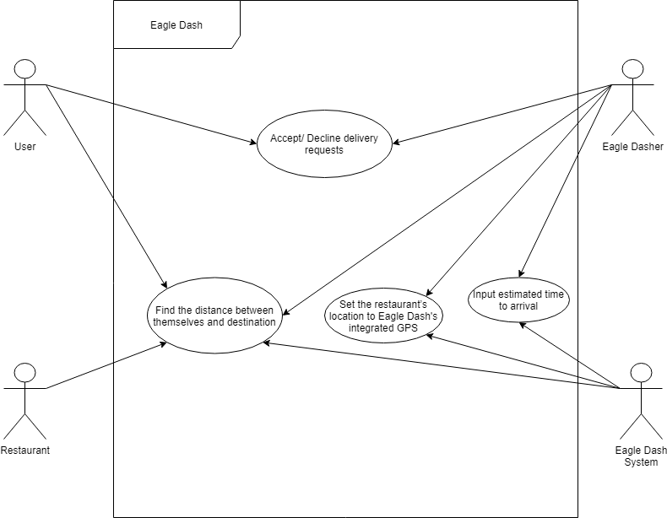

**Food Order:**

**Food Order - Use Case Description #1:**

|  |  |  |  |
| --- | --- | --- | --- |
| Use Case Name: Schedule food delivery request | | ID: 7777 | Importance Level: High |
| Primary Actor: User | Use Case Type: Detail, Essential | | |
| Stakeholders and Interests: Users - requests food to be delivered by using the Eagle Dash website / mobile app. | | | |
| Brief Description: This use case describes how users can schedule food delivery from using the Eagle Dash website / mobile app. | | | |
| Trigger: A user orders food by using Eagle Dash’s service.  Type: External | | | |
| Relationships:  Association: Eagle Dash website / mobile app  Include:  Extend:  Generalization: | | | |
| Normal Flow of Events:   1. Users visit the Eagle Dash website / mobile app. 2. Users login with their information. 3. Users select a restaurant and select the food they want based on the restaurant’s menu. 4. Users pay their fees, and the food delivery will be scheduled. | | | |
| SubFlows: | | | |
| Alternate/Exceptional Flows: | | | |

**Food Order - Use Case Description #2:**

|  |  |  |  |
| --- | --- | --- | --- |
| Use Case Name: Pay / manages payments | | ID: 7778 | Importance Level: High |
| Primary Actor: User | Use Case Type: Detail, Essential | | |
| Stakeholders and Interests: Users - pay the fees of the food that has been ordered. | | | |
| Brief Description: This use case describes how users pays and manages their payments when ordering food using the Eagle Dash’s application. | | | |
| Trigger: A user pays and manages their payment of the food they ordered.  Type: External | | | |
| Relationships:  Association: Eagle Dash website / mobile app  Include:  Extend:  Generalization: | | | |
| Normal Flow of Events:   1. Users visit the Eagle Dash website / mobile app. 2. Users login with their information. 3. Users select a restaurant and select the food they want based on the restaurant’s menu. 4. Users pay and manage their fees. | | | |
| SubFlows: | | | |
| Alternate/Exceptional Flows: | | | |

**Food Order - Use Case Description #3:**

|  |  |  |  |
| --- | --- | --- | --- |
| Use Case Name: Selects food by using the restaurant's menu | | ID: 7779 | Importance Level: High |
| Primary Actor: User | Use Case Type: Detail, Essential | | |
| Stakeholders and Interests: Users - selects the food they want to order by using the restaurant’s menu. | | | |
| Brief Description: This use case describes how users can order the food they want by using the restaurant’s menu by using the Eagle Dash website / mobile app. | | | |
| Trigger: A user selecting what food they want to order.  Type: External | | | |
| Relationships:  Association: Eagle Dash website / mobile app, Restaurant.  Include:  Extend:  Generalization: | | | |
| Normal Flow of Events:   1. Users visit the Eagle Dash website / mobile app. 2. Users login with their information. 3. Users select a restaurant and select the food they want based on the restaurant’s menu. | | | |
| SubFlows: | | | |
| Alternate/Exceptional Flows: | | | |

**Food Order - Use Case Description #4:**

|  |  |  |  |
| --- | --- | --- | --- |
| Use Case Name: Select restaurants | | ID: 7780 | Importance Level: High |
| Primary Actor: User | Use Case Type: Detail, Essential | | |
| Stakeholders and Interests: Users - selects a restaurant that they want to order food from. | | | |
| Brief Description: This use case describes how users can select the restaurants they want to order food from by using the Eagle Dash website / mobile app. | | | |
| Trigger: A user selects a restaurant.  Type: External | | | |
| Relationships:  Association: Eagle Dash website / mobile app, Restaurant.  Include:  Extend:  Generalization: | | | |
| Normal Flow of Events:   1. Users visit the Eagle Dash website / mobile app. 2. Users login with their information. 3. Users select a restaurant. | | | |
| SubFlows: | | | |
| Alternate/Exceptional Flows: | | | |

**Food Order - Use Case Description #5:**

|  |  |  |  |
| --- | --- | --- | --- |
| Use Case Name: Accept / Decline Request or Services | | ID: 7781 | Importance Level: High |
| Primary Actor: Restaurant | Use Case Type: Detail, Essential | | |
| Stakeholders and Interests: Restaurants - can accept or decline a request or services from users. | | | |
| Brief Description: This use case describes how restaurants can accept or decline a request or services from users. | | | |
| Trigger: A user selects and orders food by using Eagle Dash’s service.  Type: External | | | |
| Relationships:  Association: Eagle Dash website / mobile app, Users, Restaurant  Include:  Extend:  Generalization: | | | |
| Normal Flow of Events:   1. Users visit the Eagle Dash website / mobile app. 2. Users login with their information. 3. Users select a restaurant and select the food they want based on the restaurant’s menu. 4. Restaurants can accept or decline requests or services from users. | | | |
| SubFlows: | | | |
| Alternate/Exceptional Flows: | | | |

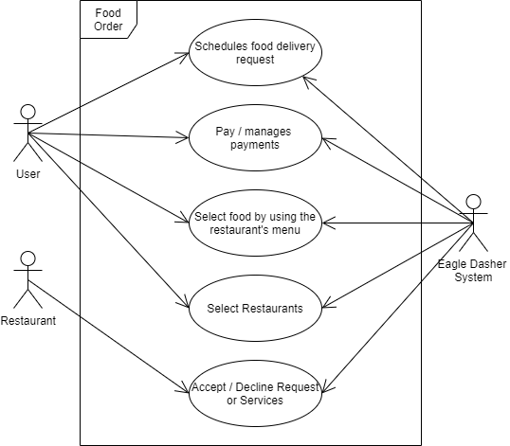

**User:**

**User - Use Case Description #1:**

|  |  |  |  |
| --- | --- | --- | --- |
| Use Case Name: Create an account | | ID: 6667 | Importance Level: High |
| Primary Actor: User | Use Case Type: Detail, Essential | | |
| Stakeholders and Interests: Users - need an account to start ordering food | | | |
| Brief Description: This use case describes how users goes to app store and download the Eagle Dash app or on the Eagle Dash website to create an account to start ordering food | | | |
| Trigger: A user wants to create an account to order food via Eagle Dash app or website  Type: External | | | |
| Relationships:  Association: User  Include:  Extend:  Generalization: | | | |
| Normal Flow of Events:   1. A user downloads the Eagle dash app or visits the Eagle Dash website. 2. Users clicks on sign in 3. Users then clicks on create account 4. User then enter email to start creating their account | | | |
| SubFlows: | | | |
| Alternate/Exceptional Flows: | | | |

**User - Use Case Description #2:**

|  |  |  |  |
| --- | --- | --- | --- |
| Use Case Name: Create username and password | | ID: 6669 | Importance Level: High |
| Primary Actor: User | Use Case Type: Detail, Essential | | |
| Stakeholders and Interests: User - creates a username and password to keep in the Eagle Dash System | | | |
| Brief Description: This use case describes how users have to create a username and password to start ordering food | | | |
| Trigger: A user wants to create an account to order food via Eagle Dash app or website  Type: External | | | |
| Relationships:  Association: User  Include:  Extend:  Generalization: | | | |
| Normal Flow of Events:   1. User makes a username 2. User makes a password | | | |
| SubFlows: | | | |
| Alternate/Exceptional Flows: | | | |

**User - Use Case Description #3:**

|  |  |  |  |
| --- | --- | --- | --- |
| Use Case Name: Set location to order food | | ID: 6670 | Importance Level: High |
| Primary Actor: User | Use Case Type: Detail, Essential | | |
| Stakeholders and Interests: User - sets their location to find restaurants to order food from | | | |
| Brief Description: This use case describes how users have to set their location to start ordering food | | | |
| Trigger: A user wants to create an account to order food via Eagle Dash app or website  Type: External | | | |
| Relationships:  Association: User, Restaurant  Include:  Extend:  Generalization: | | | |
| Normal Flow of Events:   1. User set their location 2. User choose a restaurant 3. User start ordering food | | | |
| SubFlows: | | | |
| Alternate/Exceptional Flows: | | | |

**User - Use Case Description #4:**

|  |  |  |  |
| --- | --- | --- | --- |
| Use Case Name: Enter phone number | | ID: 6668 | Importance Level: High |
| Primary Actor: User | Use Case Type: Detail, Essential | | |
| Stakeholders and Interests: Users - enter phone number for Eagle Dasher to contact | | | |
| Brief Description: This use case describes how users enter their phone number for the eagle dasher to contact them just in case there is a problem with their order | | | |
| Trigger: A user wants to create an account to order food via Eagle Dash app or website  Type: External | | | |
| Relationships:  Association: User, Eagle Dasher  Include:  Extend:  Generalization: | | | |
| Normal Flow of Events:   1. User enters their phone number 2. Eagle Dasher will contact User if there is a problem with their order | | | |
| SubFlows: | | | |
| Alternate/Exceptional Flows: | | | |

**User - Use Case Diagram:**

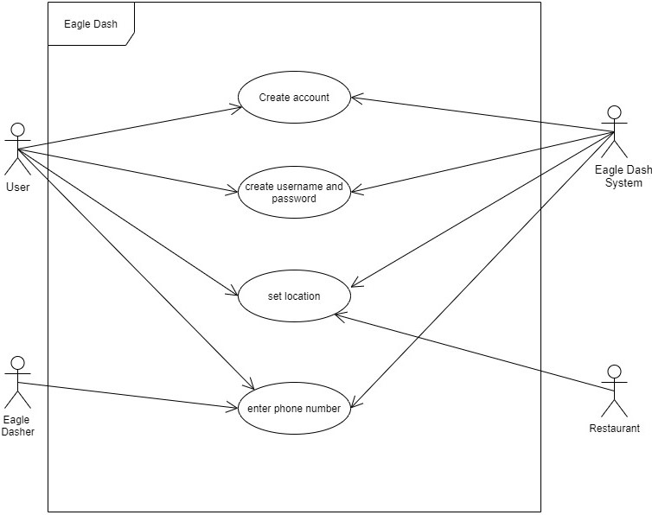

**Restaurant Notifications:**

**Restaurant Notifications - Use Case Description #1:**

|  |  |  |  |
| --- | --- | --- | --- |
| Use Case Name: Order Notification | | ID: 8881 | Importance Level: High |
| Primary Actor: Restaurant | Use Case Type: Detail, Essential | | |
| Stakeholders and Interests: Restaurant: Receives external orders from users. | | | |
| Brief Description: Restaurant receives pending order notification to be completed. | | | |
| Trigger: Order is sent and received by restaurant  Type: External | | | |
| Relationships:  Association: User, Eagle Dash System  Include:  Extend:  Generalization: | | | |
| Normal Flow of Events:   1. User sends in order through Eagle Dash System 2. Eagle Dash System sends pending order to restaurant 3. Restaurant receives notification of an order to be completed | | | |
| SubFlows: | | | |
| Alternate/Exceptional Flows: | | | |

**Restaurant Notifications - Use Case Description #2:**

|  |  |  |  |
| --- | --- | --- | --- |
| Use Case Name: Prepare Order | | ID:8882 | Importance Level: High |
| Primary Actor: Restaurant | Use Case Type: Detail, Essential | | |
| Stakeholders and Interests: Restaurant prepares order that was assigned to them. | | | |
| Brief Description: Restaurant prepares food for pending order. | | | |
| Trigger: Restaurant accepts order request from user through Eagle Dash System  Type: External | | | |
| Relationships:  Association: Restaurant  Include:  Extend:  Generalization: | | | |
| Normal Flow of Events:   1. Restaurant accepts pending order through Eagle Dash System 2. Once an order is accepted the restaurant prepares the order. | | | |
| SubFlows: | | | |
| Alternate/Exceptional Flows: | | | |

**Restaurant Notifications - Use Case Description #3:**

|  |  |  |  |
| --- | --- | --- | --- |
| Use Case Name: Completed Order Notification | | ID: 8883 | Importance Level: High |
| Primary Actor: Restaurant | Use Case Type: Detail, Essential | | |
| Stakeholders and Interests: Restaurant notifies user about the order that was completed | | | |
| Brief Description: A completed order notification is sent out through Eagle Dash System | | | |
| Trigger: Food order is completed, and a notification is sent out  Type: External | | | |
| Relationships:  Association: User, Eagle Dash System  Include:  Extend:  Generalization: | | | |
| Normal Flow of Events:   1. Restaurant Sends a completed order notification to both user and Eagle Dasher through Eagle Dash System 2. Nearby Eagle Dashers are notified of a pending order pick-up | | | |
| SubFlows: | | | |
| Alternate/Exceptional Flows: | | | |

**Restaurant Notifications - Use Case Description #4:**

|  |  |  |  |
| --- | --- | --- | --- |
| Use Case Name: Eagle Dasher | | ID: 8884 | Importance Level: High |
| Primary Actor: Eagle Dasher | Use Case Type: Detail, Essential | | |
| Stakeholders and Interests: Eagle Dasher assigned to pending order. | | | |
| Brief Description: Eagle Dasher assigned for pick-up order at restaurant, and delivery to user | | | |
| Trigger: A nearby Eagle Dasher accepts order pick-up and delivery  Type: External | | | |
| Relationships:  Association: User, Restaurant, Eagle Dash System  Include:  Extend:  Generalization: | | | |
| Normal Flow of Events:   1. A nearby Eagle Dasher accepts order pick-up at restaurant 2. Restaurant notified of Eagle Dashers arrival 3. Eagle Dasher picks up order 4. User notified of order-pick up | | | |
| SubFlows: | | | |
| Alternate/Exceptional Flows: | | | |

**Restaurant Notifications - Use Case Diagram:**

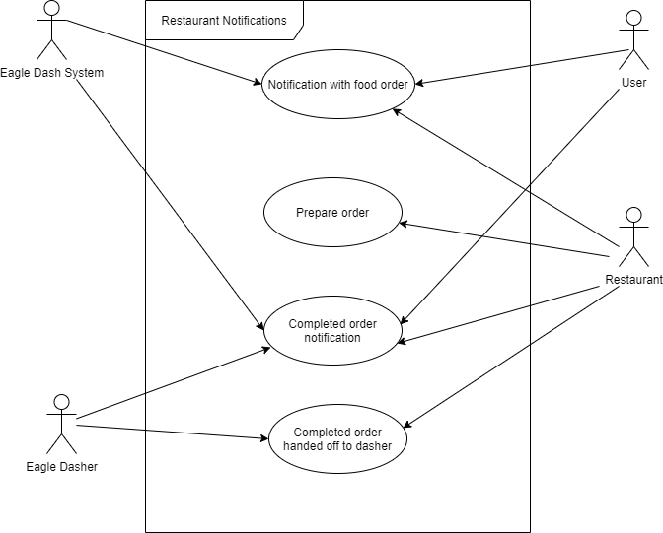

**Ratings:**

**Ratings - Use Case Description #1:**

|  |  |  |  |
| --- | --- | --- | --- |
| Use Case Name: Rate Dasher | | ID: 6675 | Importance Level: High |
| Primary Actor: User | Use Case Type: Detail, Essential | | |
| Stakeholders and Interests: Users must rate Dasher. Dasher receives a rating. | | | |
| Brief Description: This use case describes how users must rate the Dasher after Dasher completes delivery order. | | | |
| Trigger: Dasher arrives, user confirms on system that the dasher arrives. Then they are taken to the rating of the Dasher page.  Type: External | | | |
| Relationships:  Association: User, Eagle Dasher  Include:  Extend:  Generalization: | | | |
| Normal Flow of Events:   1. User confirms on the system that the dasher has delivered food. 2. User is taken to the dasher rating page and required to rate. 3. User cannot exit the page until they have rated the Dasher. 4. Dasher receives rating through Eagle Dash System. | | | |
| SubFlows: | | | |
| Alternate/Exceptional Flows: | | | |

**Ratings - Use Case Description #2:**

|  |  |  |  |
| --- | --- | --- | --- |
| Use Case Name: Tip Dasher | | ID: 6676 | Importance Level: Medium |
| Primary Actor: User | Use Case Type: Detail, Essential | | |
| Stakeholders and Interests: Users can tip Dasher after delivery through Eagle Dash. Dasher receives a tip through Eagle Dash. | | | |
| Brief Description: This use case describes how users can tip Dashers. | | | |
| Trigger: After rating dasher, user tips Dasher.  Type: External | | | |
| Relationships:  Association: User, Eagle Dasher  Include:  Extend:  Generalization: | | | |
| Normal Flow of Events:   1. After Dasher is rated, User is taken to the Dasher tipping page. 2. User cannot exit the page until action is finished. 3. User tips Dasher. 4. Dasher receives tip though Eagle Dash System. | | | |
| SubFlows: | | | |
| Alternate/Exceptional Flows: | | | |

**Ratings - Use Case Description #3:**

|  |  |  |  |
| --- | --- | --- | --- |
| Use Case Name: Rate Restaurant | | ID: 6677 | Importance Level: Low |
| Primary Actor: User | Use Case Type: Detail, Essential | | |
| Stakeholders and Interests: Users are able to rate Restaurants. Restaurants receive ratings through Eagle Dash System. | | | |
| Brief Description: This use case describes how users can rate the restaurants. | | | |
| Trigger: A user wants to rate a restaurant.  Type: External | | | |
| Relationships:  Association: User, Restaurant  Include:  Extend:  Generalization: | | | |
| Normal Flow of Events:   1. User wants to rate a restaurant. 2. User navigates the Eagle Dash System to the chosen restaurant page. 3. User sends in a rating using the Eagle Dash System. | | | |
| SubFlows: | | | |
| Alternate/Exceptional Flows: | | | |

**Ratings - Use Case Description #4:**

|  |  |  |  |
| --- | --- | --- | --- |
| Use Case Name: Tip restaurant | | ID: 6678 | Importance Level: Medium |
| Primary Actor: User | Use Case Type: Detail, Essential | | |
| Stakeholders and Interests: Users are able to tip Restaurants. | | | |
| Brief Description: This use case describes how users can tip Restaurants | | | |
| Trigger: When the user pays for food on the Eagle Dash System, they are able to enter in a tip.  Type: External | | | |
| Relationships:  Association: User, Restaurant.  Include:  Extend:  Generalization: | | | |
| Normal Flow of Events:   1. User checks-out the food on Eagle Dash System billing. 2. User is allowed to enter in any amount of tip before finalizing the payment. 3. User confirms total payment. 4. Restaurant may receive a tip. | | | |
| SubFlows: | | | |
| Alternate/Exceptional Flows: | | | |

**Ratings - Use Case Diagram**

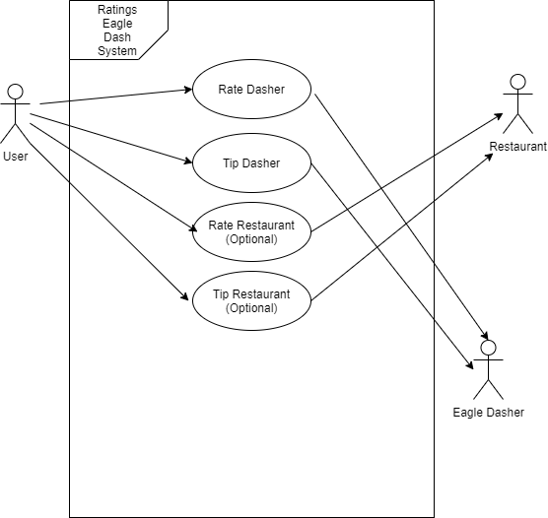

## 

## **7 Activity Diagram**

**5 diagrams**

General Main diagram: how User will order food from eagle dash

Sub categories (the details): restaurants, user, eagle dasher, ratings

**Food Order:**

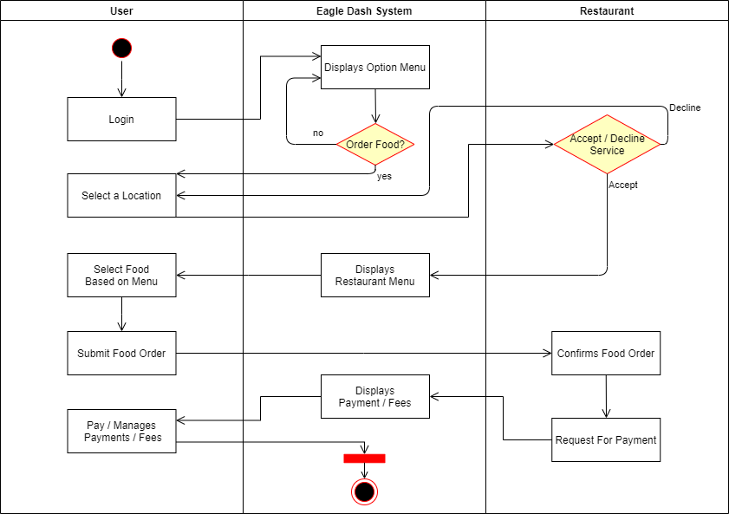

**Eagle Dasher:**

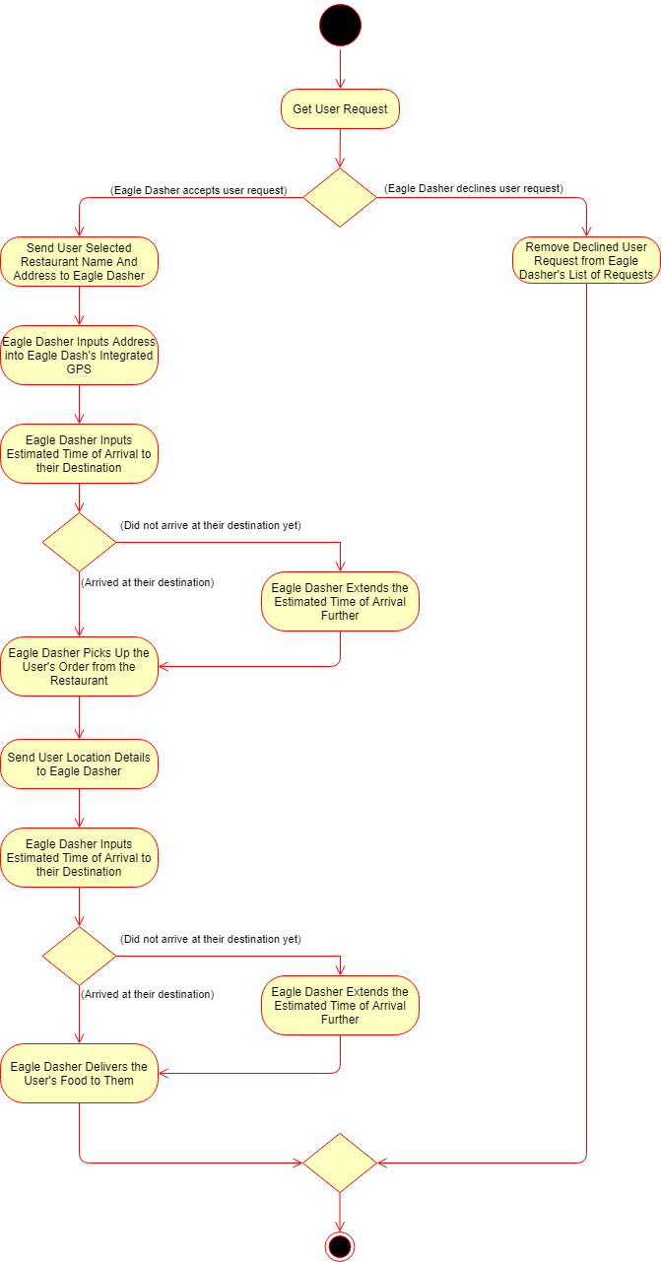

**User:**

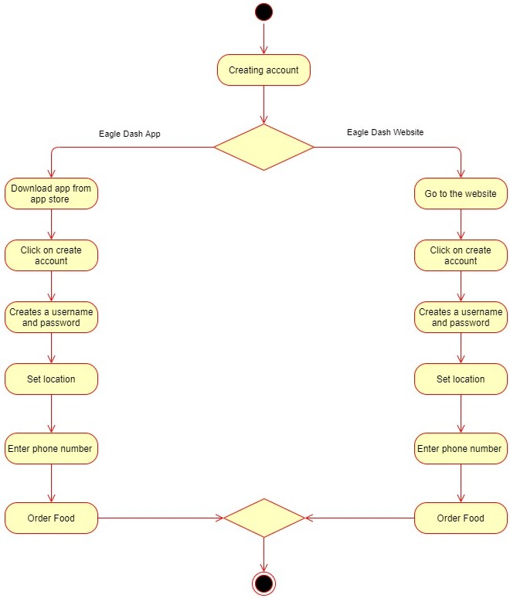

**Restaurant Notification:**

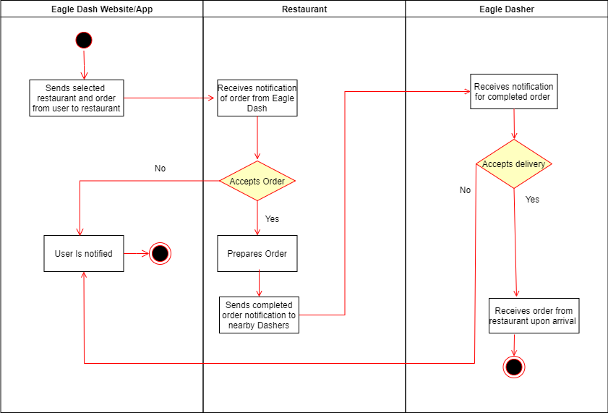

**Ratings/ tips:**

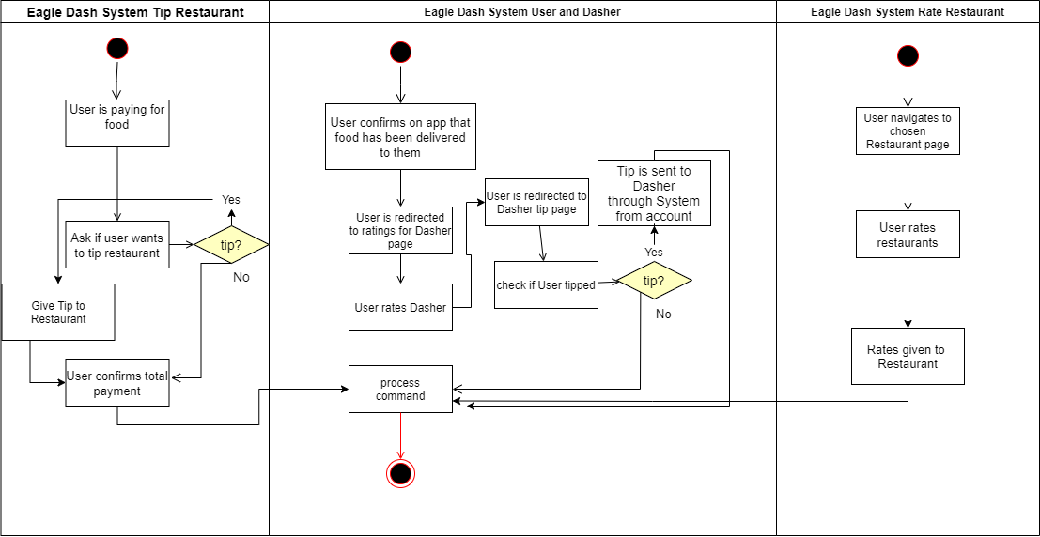

## 

## **8 Sequence Diagram**

**5 Diagrams**

**Eagle Dasher:**

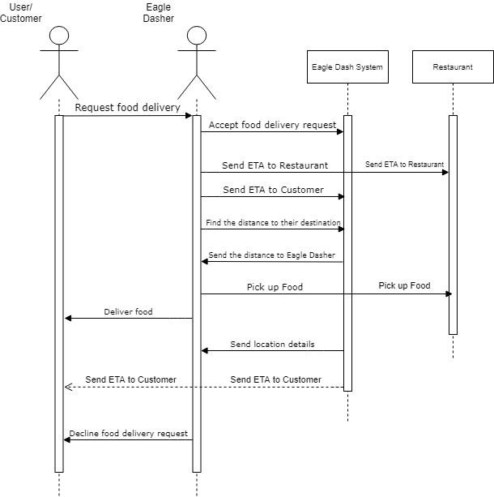

**Food Order:**

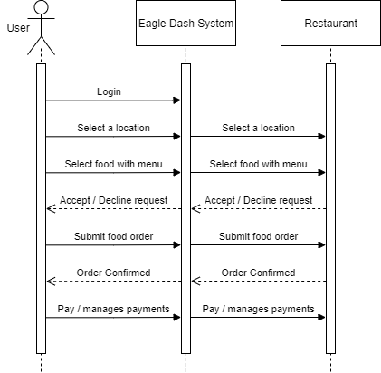

**User:**

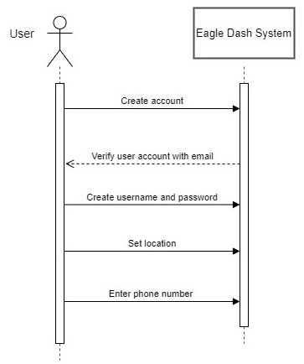

**Restaurant Notification:**

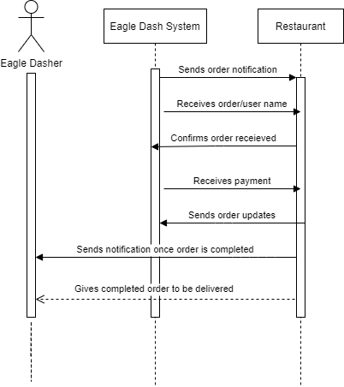

**Ratings:**

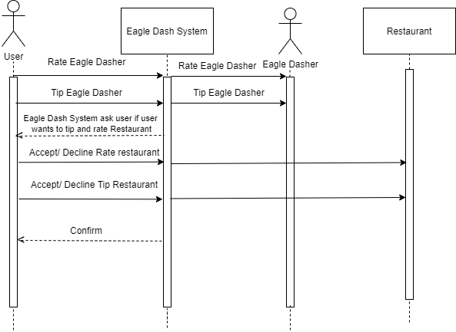

## 

## 

## **9 Class Diagram**

**Front:**

|  |  |  |  |
| --- | --- | --- | --- |
| **Class Name:** Food Order | **ID:** 2222 | | **Type:** High |
| **Description:** A person that uses the Eagle Dash website / mobile app to order food by selecting a restaurant and their menu of choice. | | | **Associated Use Cases:** 5 |
| **Responsibilities**  Responsibility1   * Eagle Dasher schedules food delivery by using the Eagle Dash website / mobile app. * Eagle Dashers uses the Eagle Dash website / mobile app to select a restaurant to order their food. * Eagle Dashers selects their food by using the restaurant's menu. * Eagle Dashers uses the Eagle Dash website or the mobile app for payment. | | **Collaborators**  Collaborator1   * Eagle Dashers * Restaurants * Eagle Dash Delivery Employee * Eagle Dash website / mobile app | |

**Back:**

|  |
| --- |
| **Attributes:**  Attribute1   * Eagle Dasher ID * Food Order ID * Eagle Dasher Name * Eagle Dasher Phone Number * Tracking ID |
| **Relationships**:  **Generalization (a-kind-of):** Eagle Dasher Food Order  **Aggregation (has-parts):**  **Other Associations:** Restaurant, Eagle Dasher, Ratings, Eagle Dash website / mobile app |

**Front:**

|  |  |  |  |
| --- | --- | --- | --- |
| **Class Name:** Eagle Dasher | **ID:** 5555 | | **Type:** High |
| **Description:**  A person that delivers food from a certain restaurant to the student/ faculty member’s location. | | | **Associated Use Cases:** 5 |
| **Responsibilities**  Responsibility1   * Eagle Dashers can accept or decline delivery requests from students/ faculty. * Eagle Dashers can set the restaurant’s location to their Eagle Dash integrated GPS. * Eagle Dashers can manually input the estimated time or let the Eagle Dash app automatically input the estimated time itself. * Eagle Dashers can find the distance from their location to their destination. | | **Collaborators**  Collaborator1   * Food Order * Restaurant * Ratings | |

**Back:**

|  |
| --- |
| **Attributes:**  Attribute1   * Eagle Dasher ID * Eagle Dasher Name * Eagle Dasher Address * Eagle Dasher Phone Number |
| **Relationships**:  **Generalization (a-kind-of):** Delivery Person  **Aggregation (has-parts):**  **Other Associations:** Food Order, Restaurant, Ratings |

**Front:**

|  |  |  |  |
| --- | --- | --- | --- |
| **Class Name:** User | **ID:** 6666 | | **Type:** High |
| **Description:**  A Student / Faculty member that uses the app or website to create an account to order food | | | **Associated Use Cases:** 5 |
| **Responsibilities**  Responsibility1   * The Students / Faculty go to app store and download the Eagle Dash app or go on the Eagle Dash website to create an account to start ordering food * Students / Faculty creates a username and password * Students / Faculty set their location to order food * Students / Faculty enters their phone number | | **Collaborators**  Collaborator1   * Food Order * Eagle Dasher * Ratings * Restaurant Notifications | |

**Back:**

|  |
| --- |
| **Attributes:**  Attribute1   * User ID * User Name * User Address * User Phone Number * User Date Of Birth * User Password |
| **Relationships**:  **Generalization (a-kind-of):** Students / Faculty  **Aggregation (has-parts):**  **Other Associations:** Food Order, Restaurant, Ratings |

**Front:**

|  |  |  |  |
| --- | --- | --- | --- |
| **Class Name:** Restaurant Notifications | **ID:** 8888 | | **Type:** High |
| **Description:**  Notification of food orders for restaurants. | | | **Associated Use Cases:** Detail Essential |
| **Responsibilities**   * The restaurant receives a notification of a pending order * The Restaurant confirms the received order. * The restaurant prepares the order. * The restaurant sends a notification out to the Eagle Dasher about the finished order. * The restaurant gives the completed order to the Eagle Dasher upon arrival. | | **Collaborators**  Users  Eagle Dasher | |

**Back:**

|  |
| --- |
| **Attributes:**  Attribute1   * Restaurant_Name * Food_Order * Order_Confirmation * Completed_Order |
| **Relationships**:  **Generalization (a-kind-of):**  **Aggregation (has-parts):**  **Other Associations:** |

**Front:**

|  |  |  |  |
| --- | --- | --- | --- |
| **Class Name:** Ratings | **ID:** 8888 | | **Type:** High |
| **Description:**  User can give ratings and tips to Eagle dasher and Restaurant on mobile app or Eagle Dash website. | | | **Associated Use Cases:** Detail Essential |
| **Responsibilities**   * Mobile app or website must collect information from the user giving the Eagle Dasher a rating * System distributes tip and ratings to the Eagle Dasher or restaurant * User gives rating to Dasher * User gives optional rating to Restaurant | | **Collaborators**  Users  Eagle Dasher  Restaurants | |

**Back:**

|  |
| --- |
| **Attributes:**  Attribute1   * Number_Of_Stars * Food_Order * Order_Confirmation * Completed_Order |
| **Relationships**:  **Generalization (a-kind-of):**  **Aggregation (has-parts):**  **Other Associations:** |

**1 diagram required**

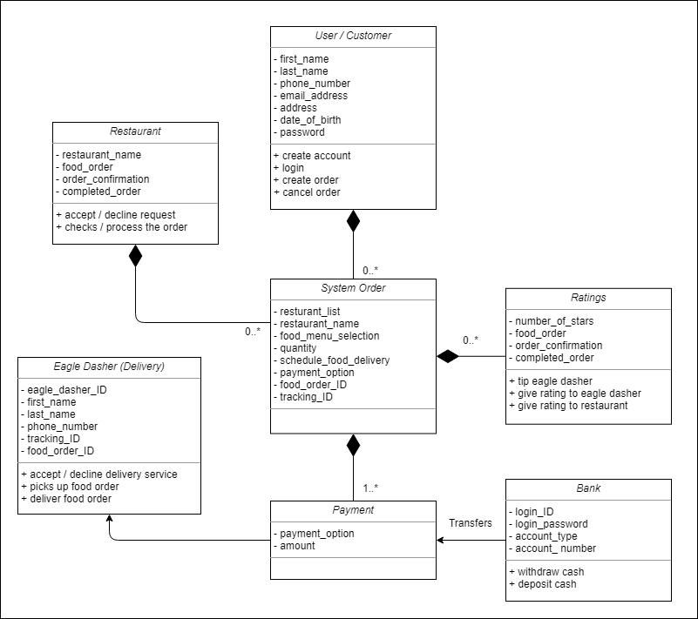

## 

## **10 Stakeholders’ Requests**

The main focus for this application is to address the biggest business concerns for Eagle Dash which are Automated User Information Management, more efficient processing, and more cost effectiveness. To address that we have Automated User Information Management. To enhance the efficiency and effectiveness of the system, we have automated payment for Eagle Dash users and automatic updates in terms of user information.

After reviewing the use case models, Eagle Dash Management would like to develop two of the following phases.

**Phase 1:**

1. Automated Payment System
2. Real Time Information Capture/ Management
3. Timetable/Sheet Management

All of these functionalities can be added later as a “need” basis. For instance, one of the activity diagrams, “Food Order”, describes an automated payment process whenever an Eagle Dash user makes an order/ request. It can be included in the next phase.

**Phase 2:**

1. Background/Credit Check of Eagle Dash user
2. Human Resources Management
3. Contract Management
4. Task/ Request Tracking, etc.

## 

1.